ECSEL JU office staff support cancer research at charity run

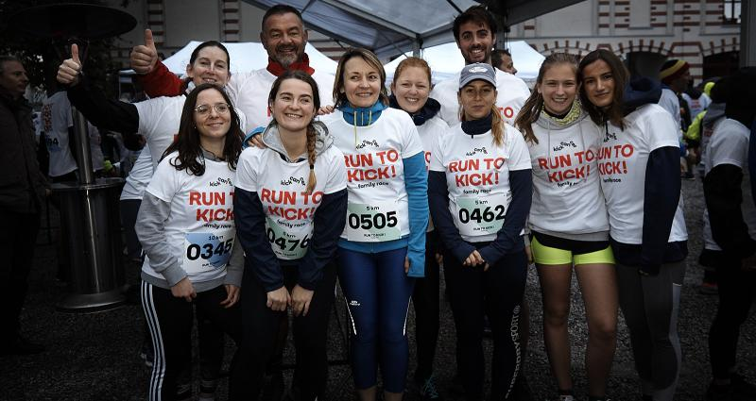

On Sunday September 29th 2019, staff of the ECSEL JU Office took part in the “Run to Kick” charity event, in support of research to fight cancer in children.

Eight members of staff, including the Executive Director Bert De Colvenaer and together with family members, faced appalling weather conditions to run the course, raising donations of €2,448 for the charity (<https://kickcancer.org/>).

The ECSEL JU staff also met up with colleagues from the Innovative Medicines Initiative (IMI). IMI’s 15-strong team raised more than €4.400 as well.

Local celebrity, singer-songwriter Angéle who actively supports the event, also ran the course. In total, the runners attracted more than €580.000 from sponsors which will be used to fund European calls for research projects addressing the special concerns of cancer in children.

Congratulations to all teams members of ECSEL JU and IMI, who selflessly donated their time and energy, braving the storms and heavy rain like the true heroes they are!